**Dear Variety Friends:**

**“We want to give EVERY eligible child a voice.”**

**I wanted to send you this link to watch the KDKA-TV piece from yesterday’s Press Conference**, which focused on giving a voice to every eligible child that’s in need in partnership with United Steelworkers and Highmark -<https://pittsburgh.cbslocal.com/2019/02/05/variety-expanding-access-to-speaking-device-for-special-needs-children/>.

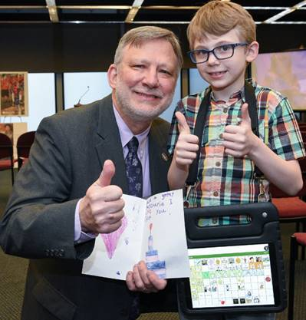

*Pictured above is Tyler and me from the Press Conference.*

**As you watch the video from yesterday’s Press Conference, I’m sure you will agree with me that Tyler, Jacob, and their families are our TRUE HEROES**. They made the time to be there yesterday and share themselves so authentically in the hopes that other children would receive communication devices.

As many of you may know, yesterday was also my birthday.

**Over the years, I’ve saved every birthday card that I received Fred Rogers, and he always wrote, “*I’m so very glad you were born*.”** As I reflect on the work Variety is doing and on yesterday’s Press Conference, I wanted to say to all of our Variety Friends that I’m so very glad that Tyler and Jacob were born – **two Variety Heroes**.

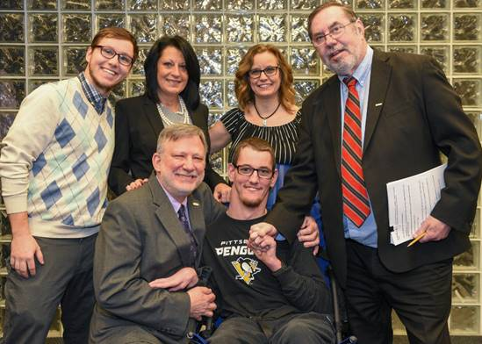

*Pictured above is Jacob (all smiles) with his brother Evan and mom Eileen surrounded by Deb Rice-Johnson, Variety Board President & Highmark, Inc. President / United Steelworkers International President Leo Gerard / and me.*

At Variety, we another quote from Fred Rogers as our tagline, “*Anyone who does anything to help a child in this life is a hero to me*.” **I couldn’t imagine a more meaningful birthday than spending it with Tyler and Jacob, who are helping more kids find a voice of their own.**

**They are our inspiration, and I’m asking if you would share the KDKA story with your networks, so that we can move this process forward of identifying every single eligible child in need of a communication device?**

My sincerest thanks to you all.

Take good care,

Charlie

**Charles P. LaVallee**

**Chief Executive Officer**